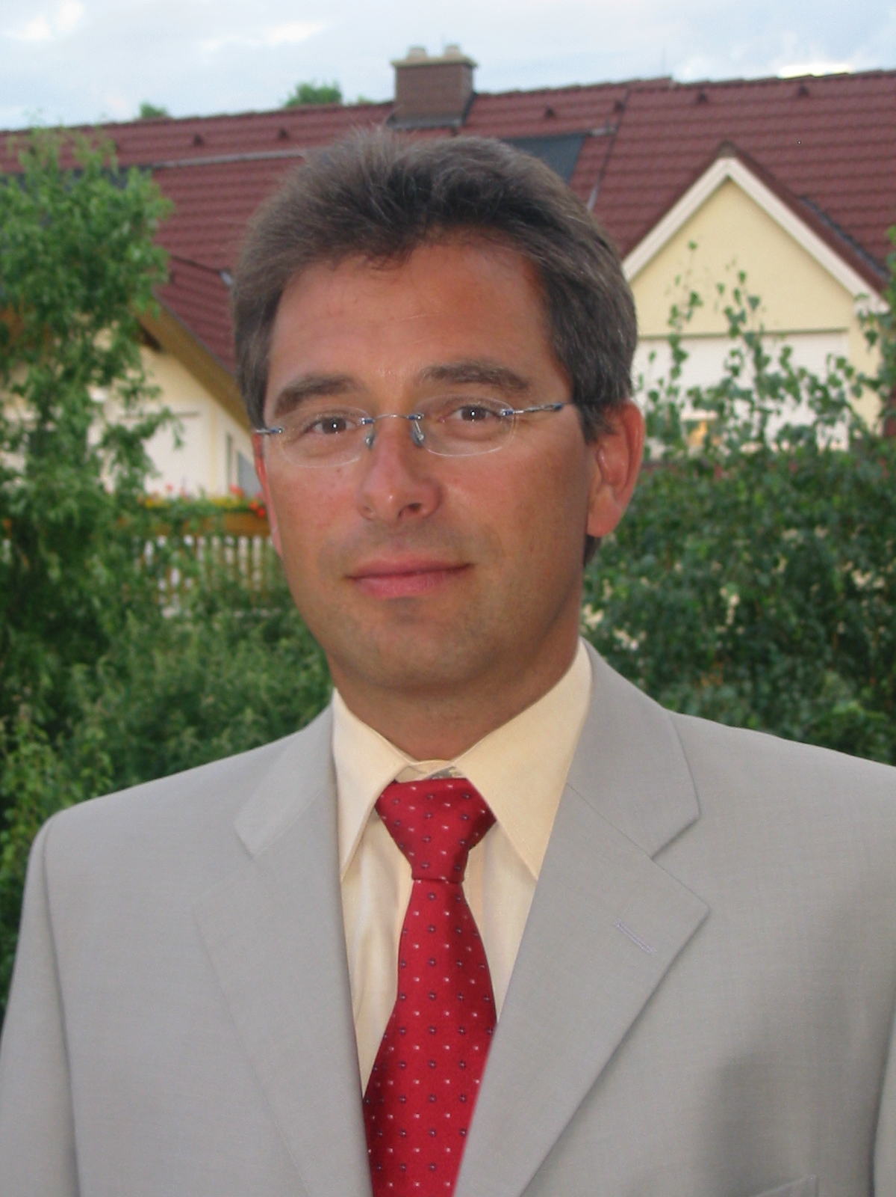
ING. ARMIN KROTKY
A-2345 Brunn am Gebirge
Krotenbachgasse 3
 mob: +(43) 699 10 378 380
fax: +(43) 699 43 378 380
mail armin@krotky.com
web http://www.armin.krotky.com
Personal Details

marital status: divorced, 3 children (14,20,21 years)
nationality: Austrian
age: 45 years
place of birth: Vienna

Work Experience
Rexel Austria & CE September 2004 - still
Vienna 23
IT Project Manager for mainly listed activities (partly):
Rollout and Implement an european wide ERP System for Finance, controlling, Logistic and Distribution.
MPLS Data Network:
Renegotiate a new contract for an european wide MPLS Network (HU/CZ/SK/SL/AT/SE/PL).
contractual Rollout
technical Rollout
Voice over IP: develop a concept for switching to VoIP within Rexel Austria, supplier selection, put out to tender, projectrealization

Connect Austria / One March 1998 – September 2003
Vienna 21
Started as Program Manager in the Network Rollout Dep., supporting the Implementation and the processes to bring the Connect Austria DCS 1800 Network on air, in accordance with the given time scale.
After 2 Months entrusted with the build up of a new regional Organisation as Area Manager for the Region Vienna 2 (approx.. 35 employees)
From January 99, takeover and merger of the second regional Office into one common organisation called Region East (approx.. 150 employees).
As Area Manger I was responsible for the following Departments
- regional Site planning (Radio and Transmission),
- Site Acquisition
- Permits and Site Construction
- Implementation
- Network Field Operation
beside the Project coordination (approx. 1200 single site Projects) one of my main tasks was to reorganise and optimise the regional Organisation to downsize the headcount to 65 employees.
Reporting directly to the CTO, i also was responsible for a yearly Budget of € 115.000.000.
Due to an extensive reorganisation of the regional Rollout Department Structure in May 2000, i took over a position in Management Support, reprting directly to the CCO.
In this function, which was an Interface between the technical and the marketing/sales departments, i was responsible for the strategic network evolution from the marketing and sales point of view as well as the geo marketing department.
High Tech / Motorola December 1989 –February 1998
Vienna 23
Started as Radio Planning Engineer for the Austrian TACS 900 (D-Net). responsible for the first 56 Turn Key Sites in the main capital cities and in Rheintal (Vlbg).
Turn Key Project Manager – responsible for Site-engineering, logistics, installation, integration & commissioning.
Change to Marketing/Program Management Department and became department leader for Program Management
Project Leader GSM Phase I for PTV/Mobilkom
Project Coordinator for the TACS Rebanding Project
Project Leader for approx. 250 Turn Key micro and pico Sites in Austria (Site Acquisition, preparation, Installation, Integration and Optimisation).
Rohde & Schwarz June 1985 – November 1989
Vienna 10
Sales Engineer RF-measurement Equipment
(main focus Communication )

Education
Volksschule
1969 - 1973
Vienna 23, Prückelmayergasse

Bundesrealgymnasium
1973 - 1978
Vienna 5, Reinprechtsdorferstraße

HTBLuVA Mödling
1978 - 1984
Höhere Abteilung für Nachrichtentechnik und Elektronik)

Training
Soscot Intensiv I MDI Oess
Projekte planen und steuern MDI Patzak/Rattay
Datenkommunikation ELMI Killian
schwierige Projekte führen Hernstein Schwarz/Heintel
professionelles Führen Motorola
Controlling für Nicht-Controller ÖCI Gabriel
das projektorientierte Unternehmen PM Gareis
Projektmanagement PM Gareis
div technische Trainings Rohde&Schwarz/Motorola/One
additional Skills and Interests
Languages: German native speaker
English, fluent
French basics
Computer MS Office XP (Word, Ecxel, Power point, Outlook)
Access, Frontpage, SQL

